CANINE PANCREATITIS

What is pancreatitis?
The pancreas is a vital organ which lies on the right side of the abdomen. It has two functions:

- To produce digestive enzymes to assist in food digestion

- To produce hormones such as insulin

When the pancreas becomes inflamed, the disorder is called pancreatitis. It is a disease process that is seen commonly in the dog. There is no age, sex, or breed predisposition.
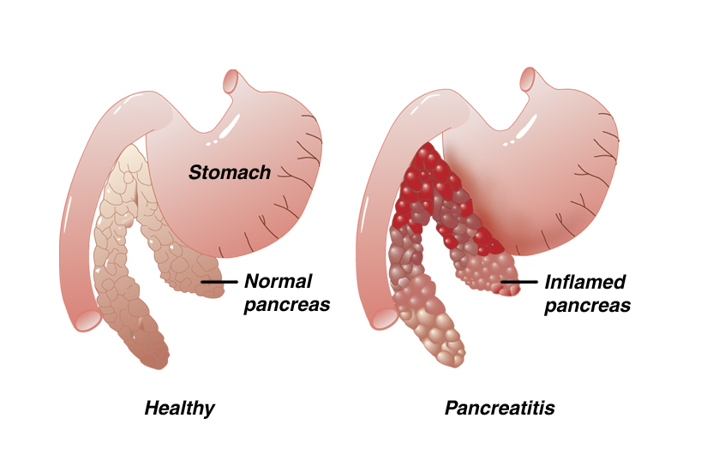
There are two main forms of acute or sudden onset pancreatitis: 1) the mild, edematous form and 2) the more severe, hemorrhagic form. A few dogs that recover from an acute episode of pancreatitis may continue to have recurrent bouts of the = disease, which is then called chronic, relapsing pancreatitis. The associated inflammation allows digestive enzymes to spill into the abdominal cavity resulting in secondary damage to the liver, bile ducts, gall bladder, and intestines.

What causes pancreatitis?
The cause of pancreatitis is not known; however, there may be several contributory factors. It is often associated with eating a rich, fatty meal. In some cases, it may be associated with the administration of corticosteroids; however, some dogs with pancreatitis do not have exposure to either.

Under normal conditions, digestive enzymes produced by the pancreas are activated when they reach the small intestine. In pancreatitis, these enzymes are activated prematurely in the pancreas instead of in the small intestine. This results in digestion of the pancreas itself. The clinical signs of pancreatitis are often variable, and the intensity of the disease will depend on the quantity of enzymes that are prematurely activated.

What are the clinical signs of pancreatitis?
The diagnosis of pancreatitis is normally based on three criteria: clinical signs, laboratory tests, and the results of radiographs (x-rays) and/or ultrasound examination. The disease is typically manifested by nausea, vomiting, fever, abdominal pain, and diarrhea. If the attack is severe, acute shock, depression, and death may occur.

Laboratory tests usually reveal an elevated white blood cell count; however, an elevated white blood cell count may also be caused by many other diseases besides pancreatitis. The elevation of pancreatic enzymes in the blood is probably the most helpful criteria in detecting pancreatic disease, but some dogs with pancreatitis will have normal enzyme levels. Radiographs and ultrasound studies may show an area of inflammation in the location of the pancreas. Unfortunately, many dogs with pancreatitis will elude detection with any of these tests. Consequently, the diagnosis of pancreatitis may be tentative in some cases and based solely on clinical signs and medical history.

How is pancreatitis treated?
The successful management of pancreatitis will depend on early diagnosis and prompt medical therapy. The mild form of the disease is best treated by resting the pancreas from its role in digestion. The only way to "turn off" the pancreas is to withhold all oral fluids and food. This approach is accompanied by intravenous fluids to maintain normal fluid and electrolyte balance. Most dogs with pancreatitis are hospitalized for two to four days while intravenous fluids are administered and food is gradually re-introduced. The presence of systemic shock necessitates the immediate and aggressive use of intravenous fluids and shock medications. Analgesics are administered due to the intense pain pancreatitis often causes.
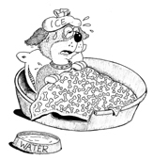

Will my dog recover?
The prognosis depends on the extent of the disease when presented and a favorable response to initial therapy. Dogs that present with shock and depression have a very guarded prognosis. Most of the mild forms of pancreatitis have a good prognosis.

Will there be any long-term problems?
There are three possible long-term complications that may follow severe or repeated pancreatitis. If a significant number of cells that produce digestive enzymes are destroyed, a lack of proper food digestion may follow. This is known as exocrine pancreatic insufficiency (EPI) and can be treated with daily administration of enzyme replacement. If a significant number of cells that produce insulin are destroyed, diabetes mellitus can result. In rare cases, adhesions between the abdominal organs may occur as a consequence of pancreatitis. However, most dogs recover with no long-term effects.

  This client information sheet is based on material written by Ernest Ward, DVM. © Copyright 2005 Lifelearn Inc. Used with permission under license. July 30, 2026

