FELINE PANCREATITIS

What is pancreatitis?
The pancreas is a vital organ located in the right side of the abdomen. It has two functions: 1) to produce enzymes that help in digestion of food and, 2) to produce hormones such as insulin. When the pancreas becomes inflamed, the condition is called pancreatitis. It is a disease process that is seen commonly in the dog and occasionally in the cat. There is no age, sex, or breed predisposition for pancreatitis.

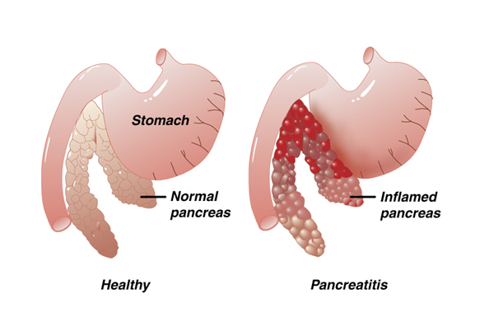
There are two main forms of acute pancreatitis or sudden onset pancreatitis: 1) the mild, edematous form and, 2) the more severe, hemorrhagic form. The inflammation associated with pancreatitis allows digestive enzymes to spill into the abdominal cavity; this may result in secondary damage to surrounding organs, such as the liver, bile ducts, gall bladder, and intestines. A few cats that recover from an acute episode of pancreatitis may continue to have recurrent bouts of pancreatitis. This is termed chronic pancreatitis.

What causes pancreatitis?
The exact cause of pancreatitis is not known. There may be more than one cause. In dogs, it is often associated with eating a rich, fatty meal or the administration of corticosteroids; however, these associations have not been found with cats. .

Under normal conditions, the digestive enzymes produced by the pancreas are activated when they reach the small intestine. In pancreatitis, the enzymes are activated prematurely in the pancreas instead of in the small intestine. This results in digestion of the pancreas itself and, thus, the clinical signs begin. The clinical signs of pancreatitis are often variable, and the intensity of the disease will depend on the extent of organ involvement.

What are the clinical signs of pancreatitis and how is it diagnosed?
The diagnosis of pancreatitis is based on three criteria: clinical signs, laboratory tests, and radiographs (x-rays) or ultrasound examination. The disease is typically manifested by nausea, vomiting, fever, abdominal pain, and diarrhea. If the attack is severe, acute shock, depression, and death may occur. Laboratory tests usually reveal an elevated white blood cell count; however, an elevated white blood cell count may also be caused by many other conditions that result in similar clinical signs. The elevation of pancreatic enzymes in the blood is probably the most helpful criteria in detecting pancreatic disease, but many cats with pancreatitis will have normal pancreatic enzyme levels. There is a more specific blood test for pancreatitis but several days may be required to obtain an answer. Radiographs and ultrasound studies may show an area of inflammation in the location of the pancreas. Unfortunately, many cats with pancreatitis will elude detection with any of these tests. Consequently, the diagnosis of pancreatitis may be tentative in many cases.

How is pancreatitis treated?
The successful management of pancreatitis will depend on early diagnosis and prompt medical therapy. The mild form of the disease is best treated by resting the pancreas from its role in digestion. The only way to "turn off" the pancreas is to withhold all oral fluids and food. The patient is supported by intravenous fluids to maintain normal fluid and electrolyte balance. In addition, pain relief and anti-inflammatory drugs are sometimes administered. The presence of shock necessitates the immediate and intense use of intravenous fluids and systemic antibiotics.
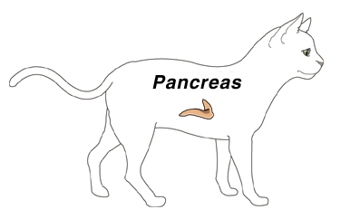

What is the prognosis for a cat diagnosed with pancreatitis?
The prognosis depends on the extent and severity of the disease when diagnosed and a favorable response to initial therapy. Cats that present with shock and depression have a very guarded prognosis. Most of the mild forms of acute pancreatitis have a good prognosis.

Will there be any long-term problems?
There are three possible long-term results that may follow severe or repeated pancreatitis.

If a significant number of cells that produce digestive enzymes are destroyed, a lack of proper food digestion may follow. This is known as exocrine pancreatic insufficiency and can be treated with daily administration of enzyme tablets or powder in the food.

If a significant number of cells that produce insulin are destroyed, diabetes mellitus can result. This can usually be treated with daily injections of insulin.

If the chronic form occurs, there may be repeated bouts of illness that are difficult to diagnose. These cats may have several days of poor appetite, fever, and lethargy. In some cases, diabetes mellitus can ultimately develop. However, most cats recover with no long-term effects.

  This client information sheet is based on material written by Ernest Ward, DVM © Copyright 2005 Lifelearn Inc. Used with permission under license. July 30, 2026

